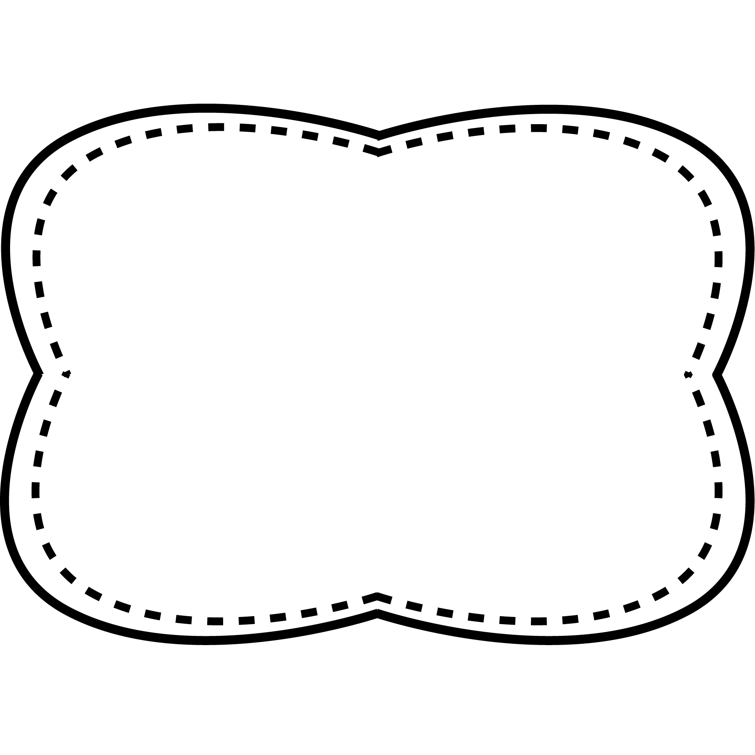

words with variant vowel

/ u /

**Spelling**

**&**

**Phonics**

**Oral Vocabulary**

Unit 6 Week 1

**Story**

“Click, Clack, Moo”

**Genre**

fantasy

**Story**

“March On”

**Genre**

nonfiction

**Story**

“Super Tools”

**Genre**

fantasy

**Essential Question**

How can we work together to make our lives better?

**Comprehension Strategy**

reread

**Comprehension Skill**

theme

**Writing Traits**

sentence fluency

**Grammar**

pronouns

**Structural Analysis**

suffixes –ful, -less

**Mechanics**

capitalize I

**argument** - a fight that uses words

**risk**- a danger or the possibility that something bad may happen

**shift**- to move something a little bit from one place to another

**conflict**- a disagreement or problem between two or more people

**fair**- when something is reasonable and follows the rules

**demand:**- ask forcefully or strongly

**emergency**- something you do not expect and need to take care of right away

spoon

truth

flew

blue

fruit

soup

rude

chew

enough

door

brought

answer

busy

eyes

*Bonus Words: demand emergency*

**High Frequency Words**

answer brought busy door enough eyes