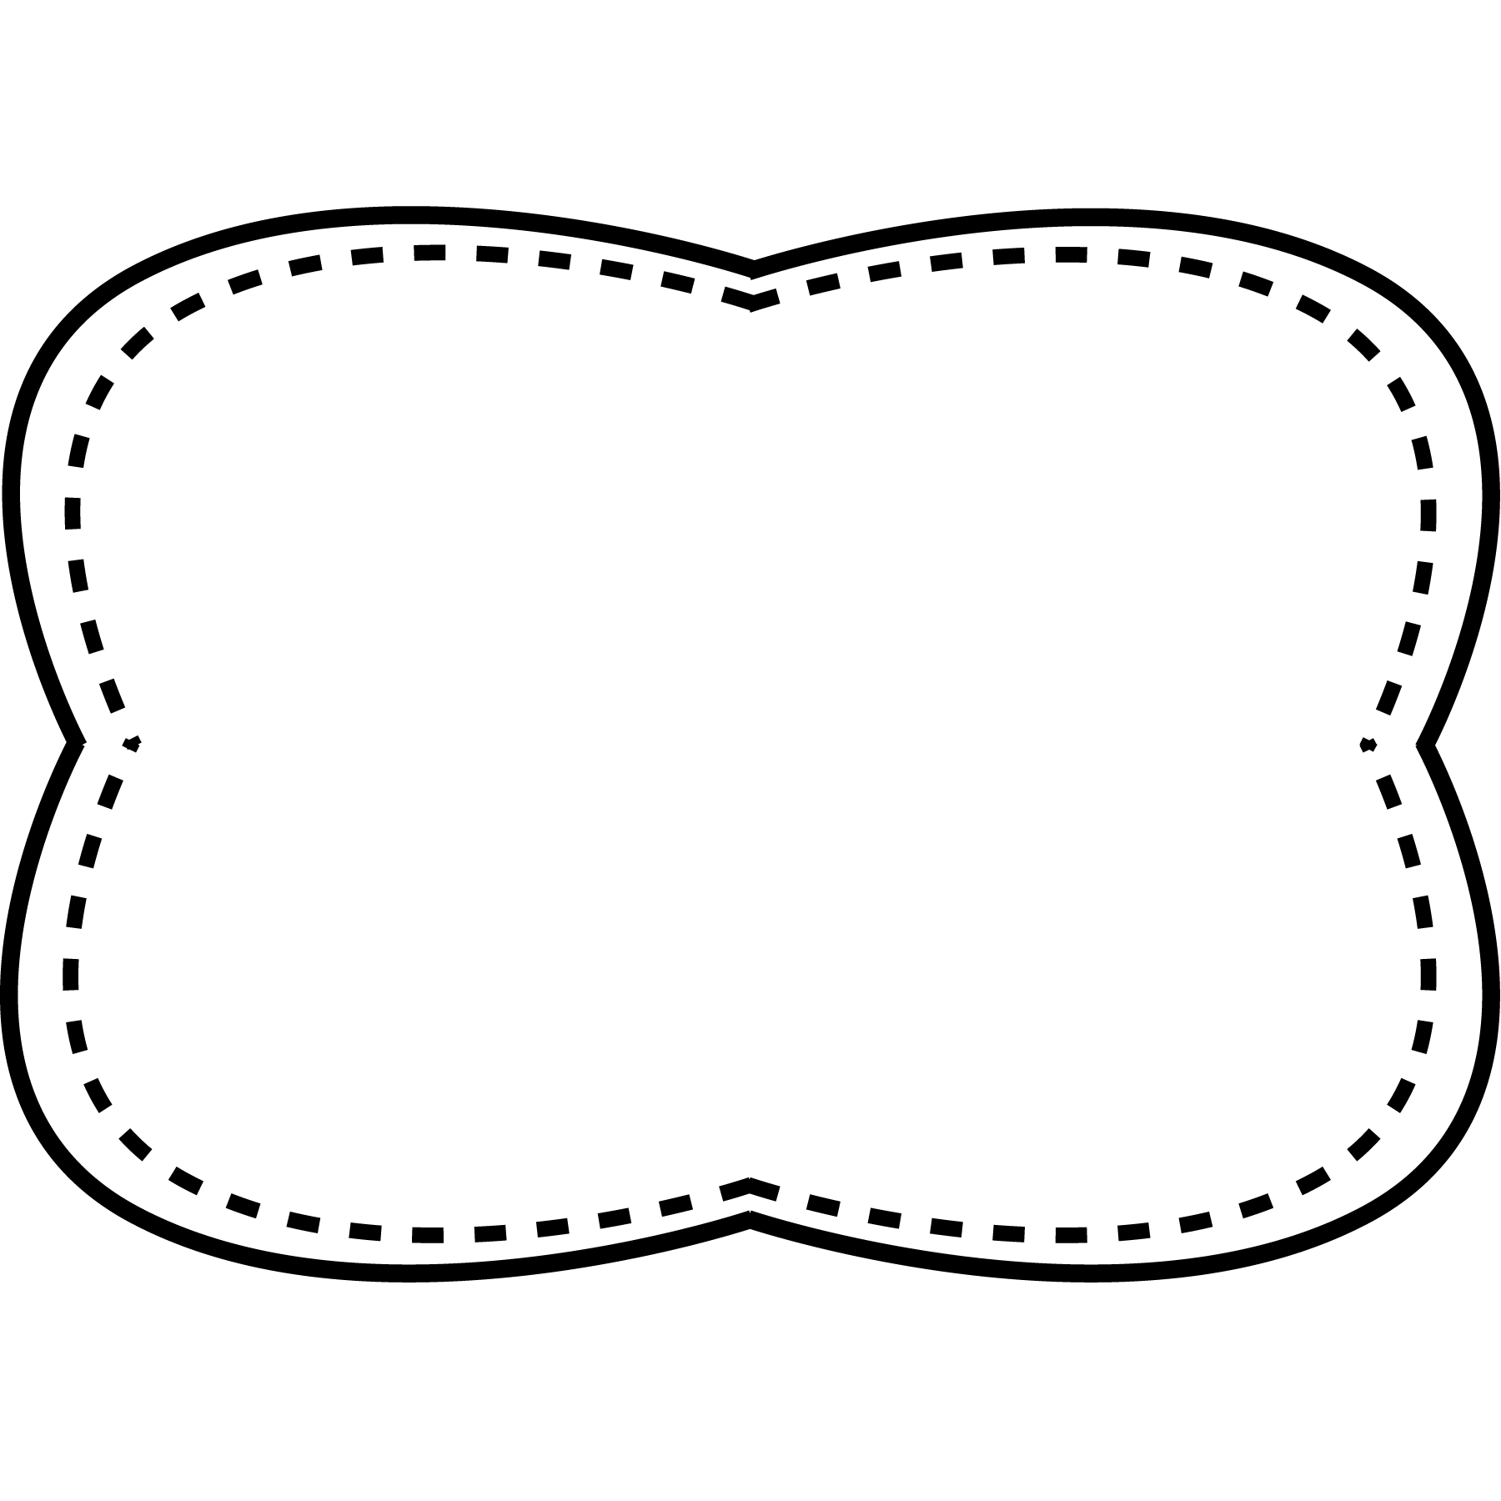

**delicious**- very tasty

**nutritious**- gives us things our body needs

**delighted**- full of joy and happiness

**enormous**- very big

**responsibility**- something you are expected to do

**Oral Vocabulary**

after buy done every soon work

**High Frequency Words**

**Story**

“From Cows to You”

**Genre**

nonfiction

**Story**

“A Food Chart”

**Genre**

nonfiction

**Story**

“A Look at Breakfast”

**Genre**

nonfiction

**Spelling**

**&**

**Phonics**

Words with

–ook, -ood

book

look

cook

took

hood

wood

booklet

cookie

after

buy

done

every

soon

work

Unit 3 Week 5

**Essential Question**

How do we get our food?

**Comprehension Strategy**

reread

**Comprehension Skill**

connections within text:

sequence

**Writing Traits**

ideas

**Grammar**

contractions with not

**Structural Analysis**

inflectional endings –ed, -ing

**Mechanics**

apostrophes in contractions