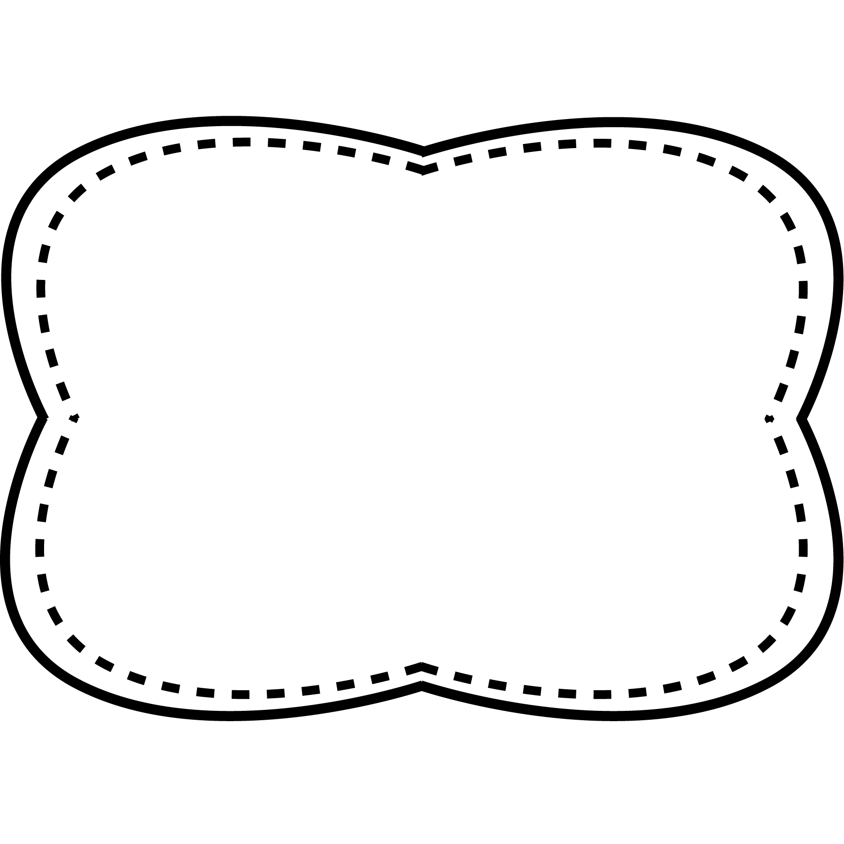

**Spelling**

**&**

**Phonics**

Words with

o _ e, u _ e

**century**- 100 years

**past**- time that has already happened

**entertainment**- things people do to have fun

**future**- time that hasn’t happened yet

**present**- time that is happening right now

**Oral Vocabulary**

**High Frequency Words**

ago boy girl how old people

**Story**

“Long ago and Now”

**Genre**

nonfiction

**Story**

“From Horse to Plane”

**Genre**

nonfiction

**Story**

“Life at Home”

**Genre**

Nonfiction

hope

nose

note

rope

cute

cube

close

quote

ago

old

how

boy

girl

people

**Essential Question**

How is life different than it was

a long time ago?

**Comprehension Strategy**

reread

**Comprehension Skill**

connections within text:

compare and contrast

**Writing Traits**

ideas

**Grammar**

is and are

**Structural Analysis**

CVCe syllables

**Mechanics**

commas in dates

Unit 3 Week 4