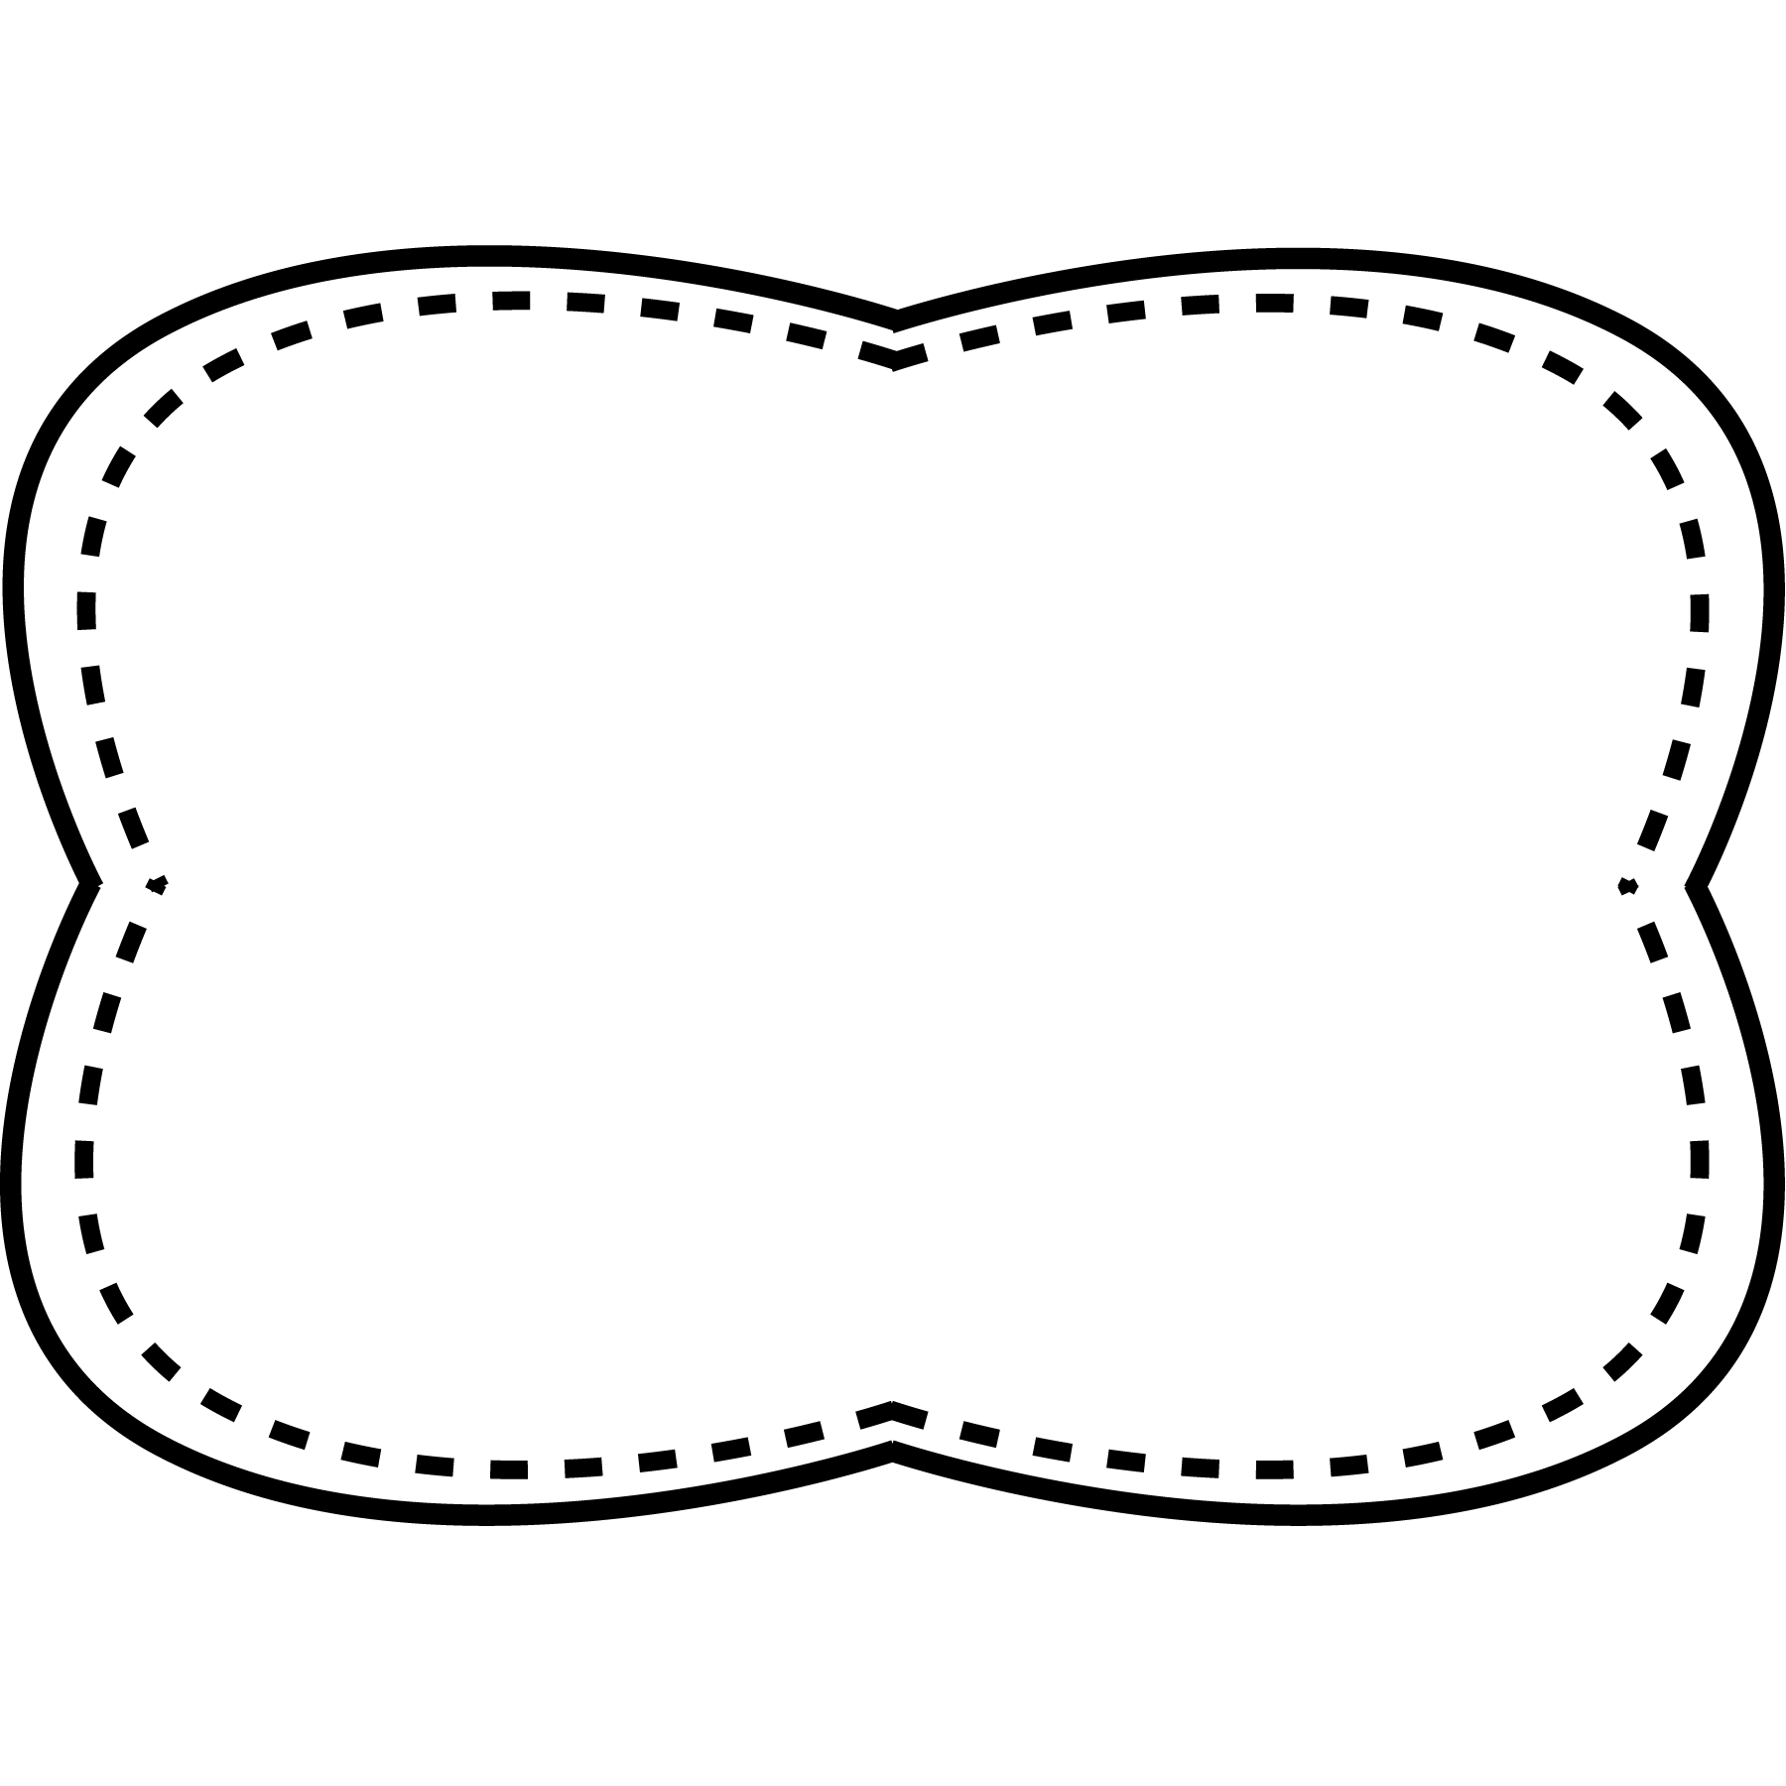

born

corn

core

more

roar

soar

pork

store

learn

sure

right

guess

better

began

*Bonus Words: idea unusual*

words with

or, ore, oar

**Spelling**

**&**

**Phonics**

**idea**- a picture or thought you get in your mind

**unusual**- not common

**curious**: to be interested in something and want to know more about it

**improve**: to make something better

**complicated**: something that has many parts and is difficult to understand

**device**: an object made to do a certain job

**imagine**: to think of something that isn’t real or that hasn’t happened

**Story**

“Thomas Edison Inventor”

**Genre**

biography

**Story**

“Windshield Wipers”

“Scissors”

**Genre**

poetry

**Story**

“The Story of a Robot Inventor”

**Genre**

biography

**Essential Question**

What inventions do you know about?

**Comprehension Strategy**

ask and answer questions

**Comprehension Skill**

connections within text:

problem and solution

**Writing Traits**

word choice

**Grammar**

adjectives that compare

**Structural Analysis**

abbreviations

**Mechanics**

capitalize days, months, and holidays

began better guess learn right sure

**High Frequency Words**

Unit 5 Week 3

**Oral Vocabulary**