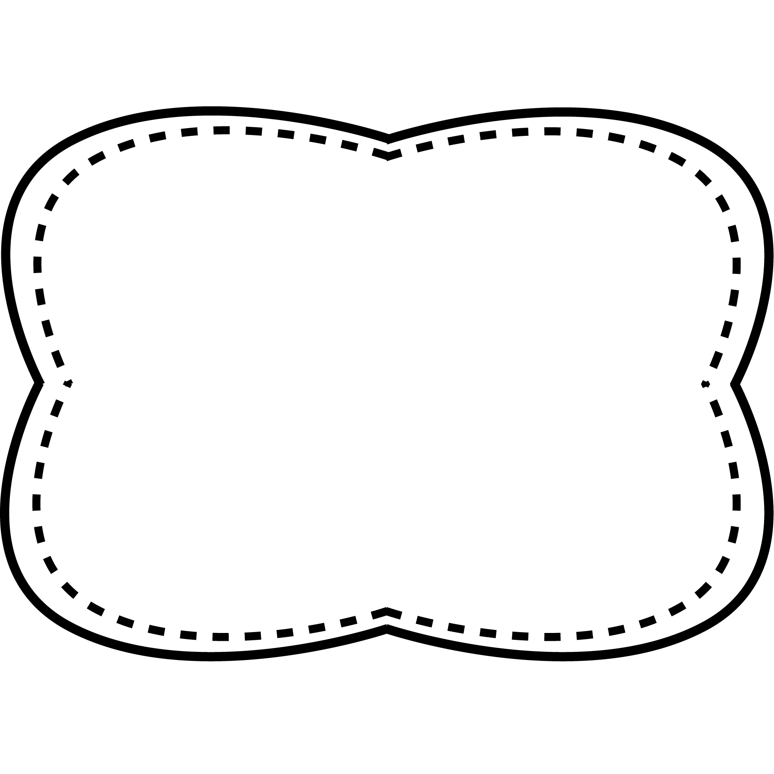

**Story**

“The Big Yuca Plant”

**Genre**

play

**Story**

“How Plants Grow”

**Genre**

Nonfiction

**Story**

“Time to Plant”

**Genre**

Play

**Spelling**

**&**

**Phonics**

long i

i _ e

like

spike

ride

hide

bike

mine

shine

twice

water

should

green

grow

pretty

together

**bloom**- when flower buds open

**sprout**- when seeds begin to grow

**assist**- to help

**grasped**- held tightly

**spied**- noticed or saw

**Oral Vocabulary**

green grow pretty should together water

**High Frequency Words**

**Essential Question**

How do plants change as they grow?

**Comprehension Strategy**

make and confirm predictions

**Comprehension Skill**

plot: sequence

**Writing Traits**

word choice

**Grammar**

present-tense verbs

**Structural Analysis**

plurals

**Mechanics**

titles of plays

Unit 3 Week 2