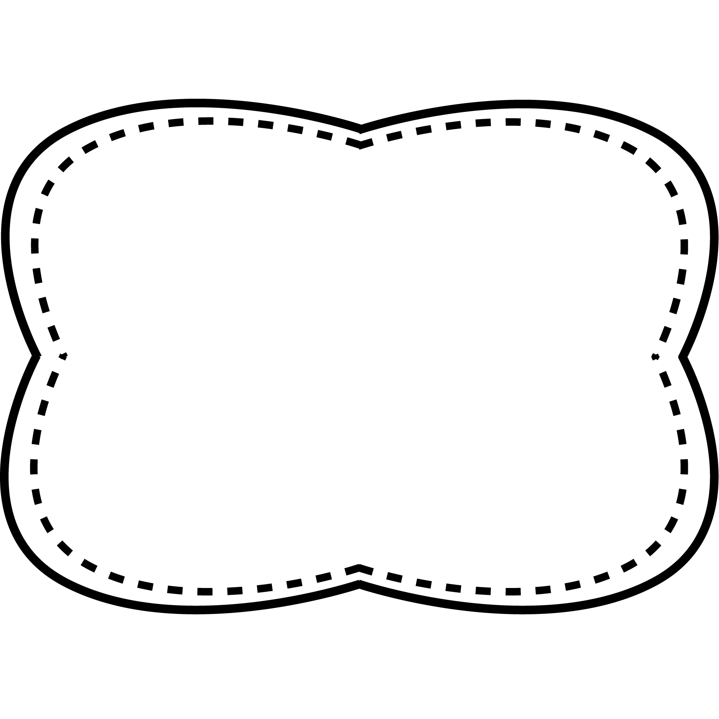

**Spelling**

**&**

**Phonics**

long a

a_e

make

take

came

game

gate

late

page

space

some

today

away

way

now

why

**calendar**- chart that shows the days, weeks, and months in a year

**occasion**- a special time or event

**weekend**- Saturday and Sunday

**immediately**- right away, without waiting

**schedule**- timetable showing when things happen

**Oral Vocabulary**

away now some today way why

**High Frequency Words**

**Story**

“On My Way to School”

**Genre**

fiction

**Story**

“It’s About Time”

**Genre**

Nonfiction

**Story**

“Nate the Snake is Late”

**Genre**

Fantasy

**Essential Question**

How do we measure time?

**Comprehension Strategy**

make and confirm predictions

**Comprehension Skill**

character, setting, plot

**Writing Traits**

word choice

**Grammar**

verbs

**Structural Analysis**

contractions with not

**Mechanics**

commas in a series

Unit 3 Week 1