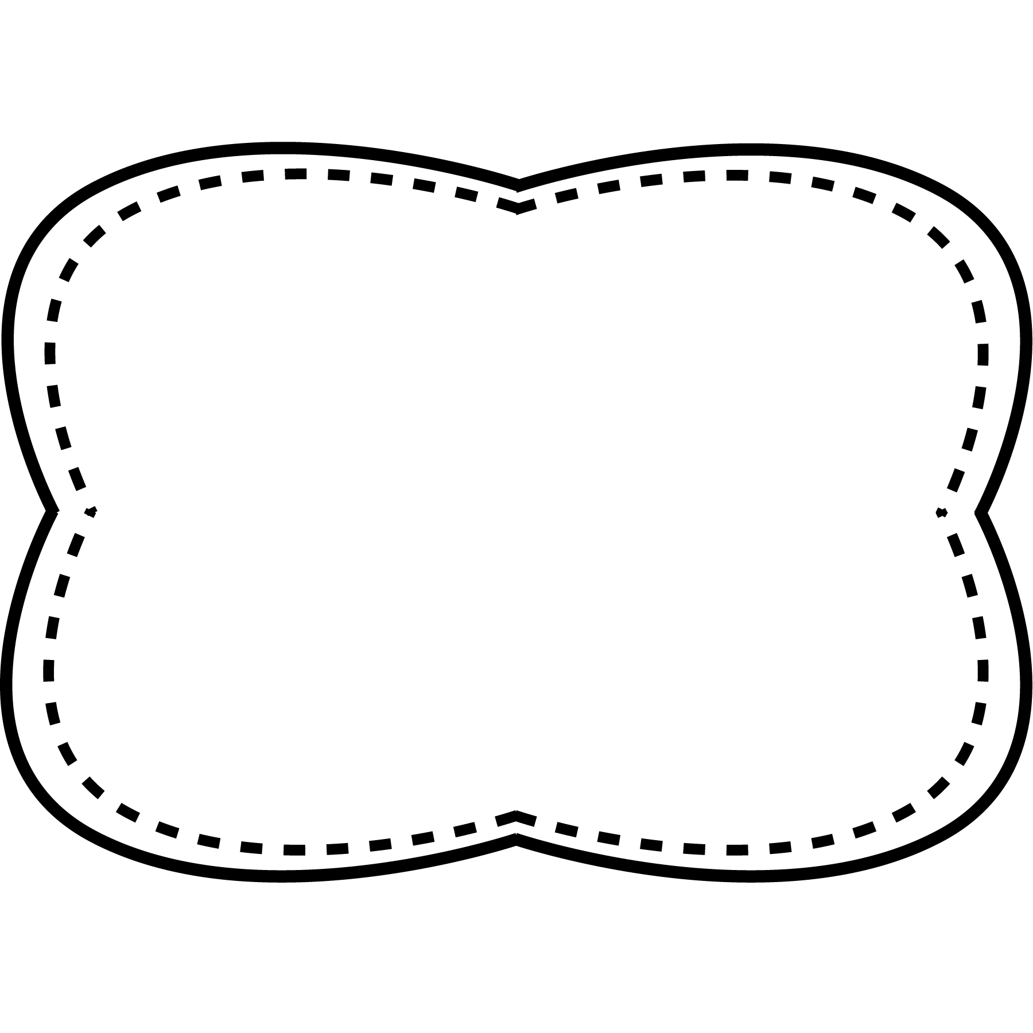

**Story**

“Fun with Maps”

**Genre**

Nonfiction

**Story**

“North, East, South, or West?”

**Genre**

Nonfiction

**Story**

“Which Way on the Map?”

**Genre**

Nonfiction

**Essential Question**

How can you find your way around?

**Comprehension Strategy**

reread

**Comprehension Skill**

main topic and key details

**Writing Traits**

ideas

**Grammar**

irregular plural nouns

**Structural Analysis**

Inflectional endings –es

**Mechanics**

capitalize letters and periods

**High Frequency Words**

around by many place walk

whip

whale

catch

match

chin

graph

chop

phone

many

around

by

place

walk

Unit 2 Week 5

**Oral Vocabulary**

**Spelling**

**&**

**Phonics**

words with ch, -tch,

wh, ph

**locate**- to find

**route**- road or way to take to get somewhere

**height**- how tall something is

**model**- a small copy of something large

**separate**- keep apart