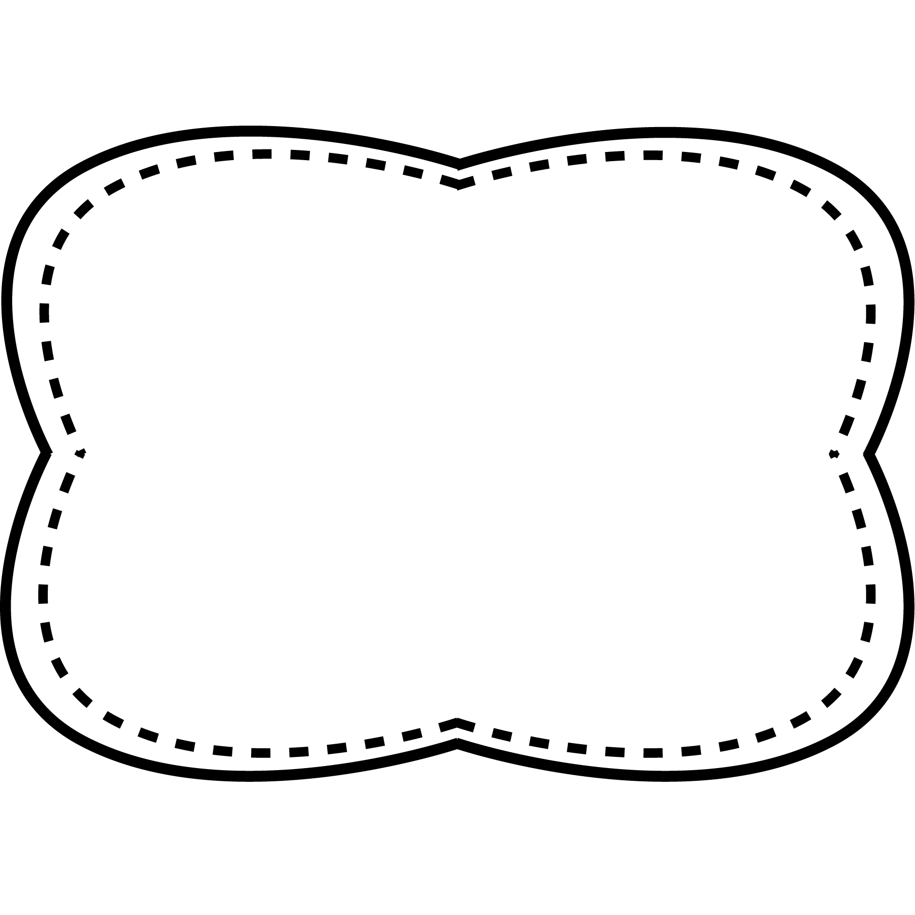

**Essential Question**

How does your body move?

**Comprehension Strategy**

ask and answer questions

**Comprehension Skill**

key details

**Writing Traits**

organization

**Grammar**

writing sentences

**Structural Analysis**

possessives

**Mechanics**

capitalization and punctuation

**exercise**- activities you do with your body to stay healthy and become stronger

**physical**- about the body

**agree**- have the same idea about something

**difficult**- hard to do or full of problems

**exhausted**- very, very tired

**Oral Vocabulary**

jump move run two

branch

stamp

spill

spin

grab

grass

drop

drip

run

jump

two

move

-r and s- blends

**Spelling**

**&**

**Phonics**

**High Frequency Words**

**Story**

*Move It!*

**Genre**

Nonfiction

**Story**

“Using Diagrams”

**Genre**

Nonfiction

**Story**

*Move and Grin!*

**Genre**

Nonfiction

Unit 1 Week 5