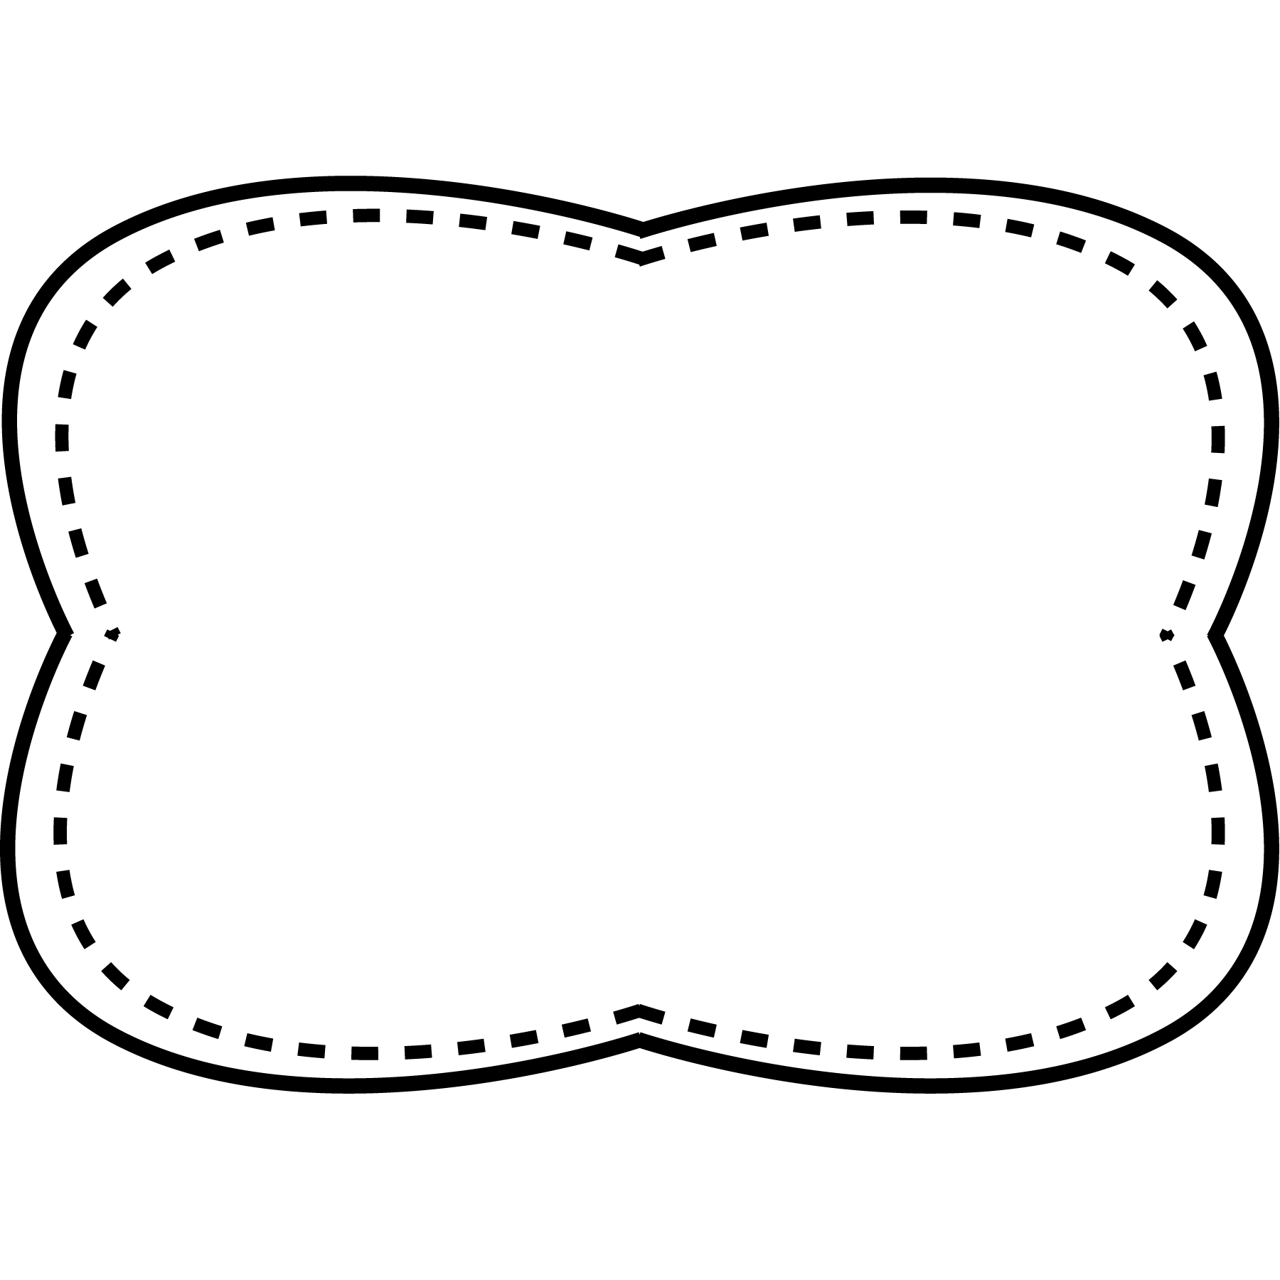

spoil

coin

join

joy

toy

boy

enjoy

voice

build

fall

above

knew

money

toward

*Bonus Words: balance section*

words with

oi, oy

**Spelling**

**&**

**Phonics**

**Essential Question**

How do things get built?

**Comprehension Strategy**

ask and answer questions

**Comprehension Skill**

cause and effect

**Writing Traits**

organization

**Grammar**

prepositions

**Structural Analysis**

Final stable syllables

**Mechanics**

abbreviations

**Story**

“Building Bridges”

**Genre**

nonfiction

**Story**

“Small Joy”

**Genre**

nonfiction

**Story**

“The Joy of a Ship”

**Genre**

nonfiction

Unit 5 Week 5

**Oral Vocabulary**

**balance**- stay in place without falling

**section**- small part of something bigger

**project-** something you work on

**structure-** something that has been built

**contented-** to be pleased or happy

**intend-** you are planning to do something

**marvelous-** wonderful or excellent

**High Frequency Words**

above build fall knew money toward