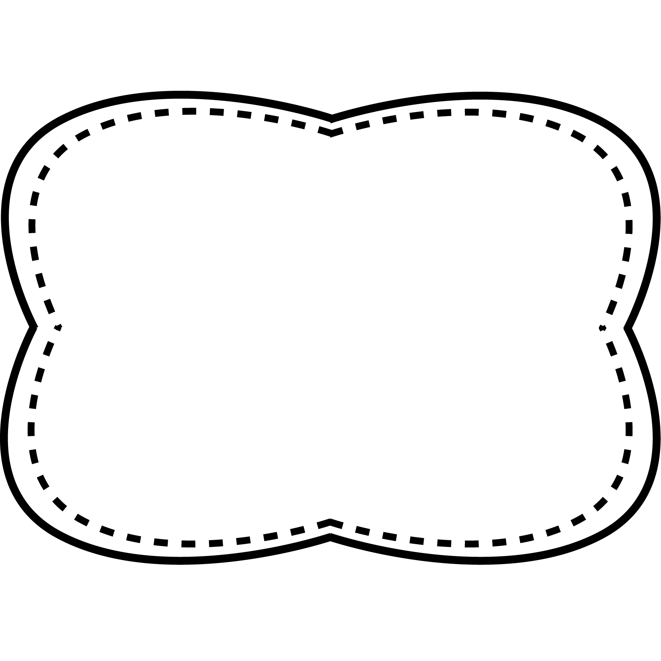

cow

town

mouse

how

out

mouth

brown

cloud

nothing

early

color

instead

oh

thought

*Bonus Words: scrambled suddenly*

words with

ou, ow

**Spelling**

**&**

**Phonics**

**Story**

“Whistle for Willie”

**Genre**

fiction

**Story**

“Shake! Strike! Strum!”

**Genre**

nonfiction

**Story**

“Now, What’s That Sound?”

**Genre**

realistic fiction

**Essential Question**

What sound can you hear?

How are they made?

**Comprehension Strategy**

ask and answer questions

**Comprehension Skill**

plot: problem and solution

**Writing Traits**

sentence fluency

**Grammar**

using a, an, this, and that

**Structural Analysis**

inflectional endings –er, -est

**Mechanics**

capitalize / underline book titles

**High Frequency Words**

color early instead nothing oh thought

**scrambled**- climbed or walked quickly

**suddenly**- quickly, without notice

**senses**- what gives us information about the world around us

**volume**- the level of sound – whether loud or soft

**distract**- to take attention away from what you were focused on

**nervous**- to feel worried

**squeaky**- a high-pitched sound

**Oral Vocabulary**

Unit 5 Week 4